Ex.no:2 | EDA-Data Import and Export

Aim:

Algorithm:

Program:
CSV import
# Import libraries
import pandas as pd
df = pd.read_csv("medical_dataset_1100_rows_v2.csv")
print(df)
print(df.head())
print(df.info())
print(df.describe())
Excel import
# Import libraries
import pandas as pd
df = pd.read_excel("medical_dataset_1100_rows_v2.xlsx")
print(df)
print(df.head())
print(df.info())
print(df.describe())
SQL import
import sqlite3
import pandas as pd
conn = sqlite3.connect(":memory:")
cursor = conn.cursor()
with open("medical_dataset_1100_rows_v2.sql", "r") as file:
sql_script = file.read()
cursor.executescript(sql_script)
tables = pd.read_sql_query(
"SELECT name FROM sqlite_master WHERE type='table';",
conn
)
print("Tables in Database:")
print(tables)
# Get first table name
table_name = tables.iloc[0, 0]
# Read data
df = pd.read_sql_query(f"SELECT * FROM {table_name}", conn)
print("\n===== HEAD =====")
print(df.head())
print("\n===== INFO =====")
df.info()
conn.close()
CSV export
df.to_csv("medical_dataset_export.csv", index=False)
print("CSV exported successfully!")
Excel export
df.to_excel("medical_dataset_export.xlsx", index=False)
print("Excel file exported successfully!")
SQL export
import sqlite3

# Create/connect to SQLite database
conn = sqlite3.connect("medical_dataset.db")

# Export DataFrame to SQL table
df.to_sql(
"medical_records", # Table name
conn,
if_exists="replace", # replace existing table
index=False
)
print("Data exported successfully to SQLite database!")
conn.close()
Output:
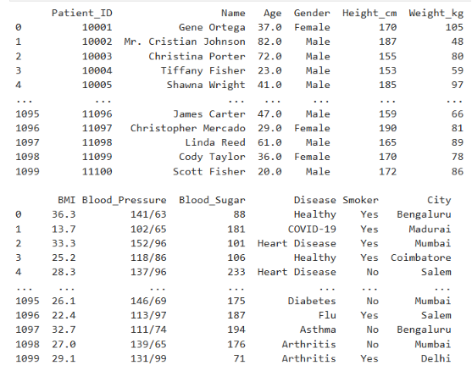
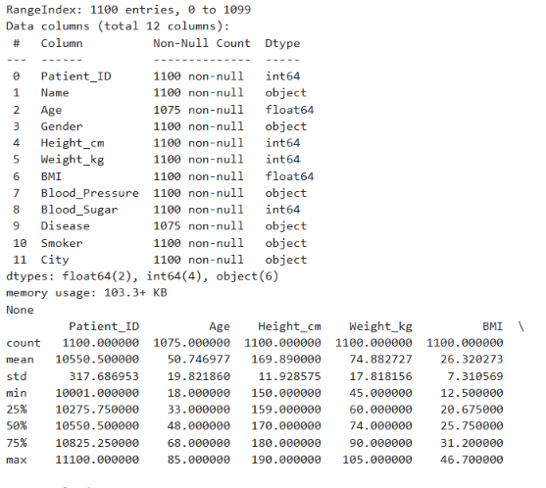
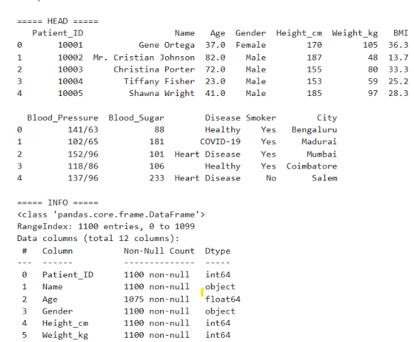

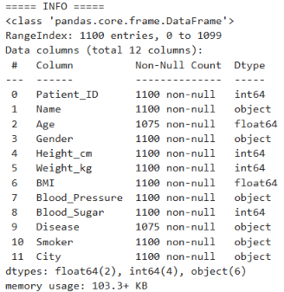

Result:

